# Image processing course – homework #2 imageprocessinghaifau@gmail.com

**Lost Wormhole**

In this homework you will be writing python functions which perform Geometric operations on an image (left) to create a **lost wormhole** poster (right):

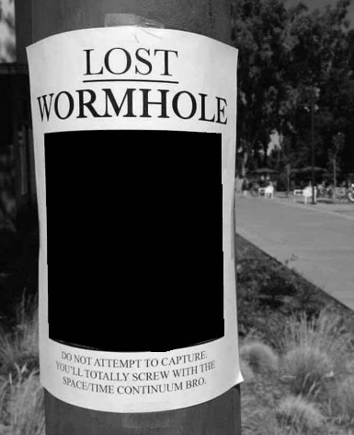 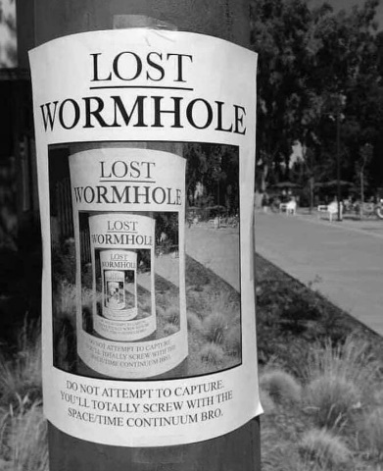

To do this, we’ll need three functions only:  
(Use helping functions: np.linalg.pinv , np.linalg.inv, np.matmul, round)

1)   **find_transform(pointset1, pointset2)**  
            This function calculates the global transformation T that transform pointset1 to pointset2.

**Input**:      pointset1, pointset2 – arrays of size Nx2

N is the number of points, 2 is the x and y.

**Output**:   T – transformation matrix of size 3x3.

**Method**:  T fulfills the equation: $Pointset2 = T * pointset1$

To find T, you’ll need to build the matrices X, X’ in slides 58-62 in lecture5.

2) **transform_image(image, T)**

This function generates an image that is the result of applying T on image.

**Input**:      image – 2D matrix with gray levels [0..255]

T – transformation matrix of size 3x3.

**Output**:   new_image - 2D matrix with gray levels [0..255]

**Method**:

1. Define a new_image full of zeros the size of the given image.
2. Iterate over coordinates [x’,y’] of the pixels of the new image
3. Answer the question: which pixel [x,y] in image is transformed to [x’,y’] in new image
4. Use nearest neighbor interpolation: just use round on the result of 3.
5. Insert gray level inside [x’,y’]

3) **create_wormhole(image, T, iter)**

This function builds the final image.

**Input**:      image – 2D matrix with gray levels [0..255]

T – transformation matrix of size 3x3.

Iter – an integer number

**Output**:   new_image - 2D matrix with gray levels [0..255]

**Method**:  this function iterates to create the image inside image (wormhole) multiple times (number of times is indicated with the variable iter).

Example: iter=5. The function creates 5 images.

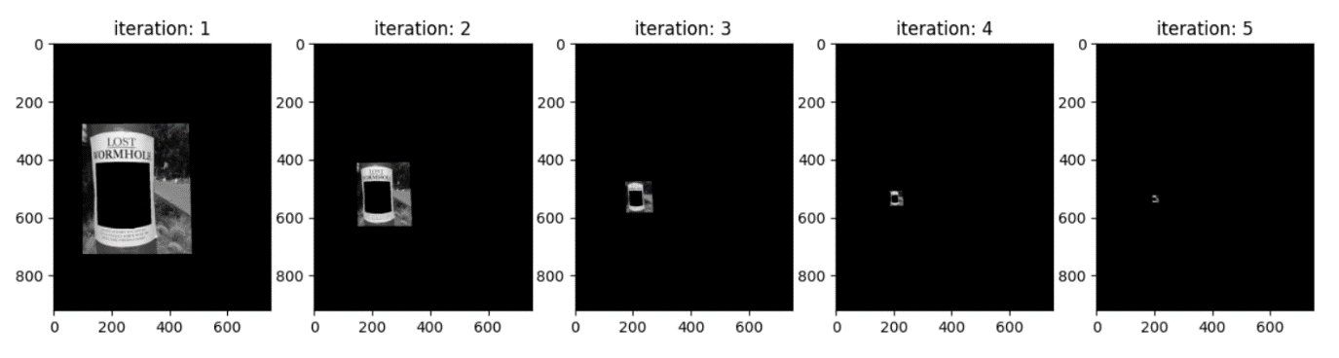

Summing the original image with all 5 images will generate the wormhole:

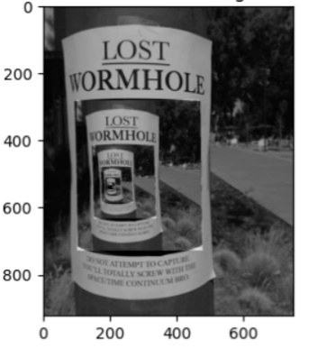

You only need to return the final image (the full wormhole).

**Note**: this function is not as hard as it looks. It is very easy if you implemented the previous functions correctly. Iteration1 is just applying T to the original image. How do you get iterations 2-5?

**Hint**: if T was scaling by 0.5. then iteration2 is scaling by 0.25, iteration3 is scaling by 0.125 and so on. (in this homework T is more than just scalling).

You are provided with two files **hw2_123456789.py**, in it you’ll find blank functions and two arrays src_points (the red points below) and dst_points (the blue ones). The points are in matching order.

**Important note**: the points (1-8) are given in [x,y], where x is the horizontal axis and y is the vertical. When finding the transform use them.

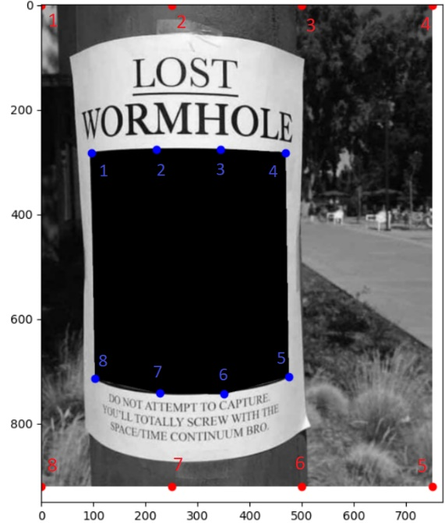

Be careful in function transform_image to the x,y.   
As I said in class, the x,y are flipped when it comes to image indices.   
Example: image[x,y] - x is the rows of the matrix (vertical axis) and y is the columns (horizontal axis).

**Submission**

Please submit one .py file with the functions implemented

Name the file **hw2_123456789.py** (or in case of pair: **hw2_123456789_987654321.py**)

**(Replace 123456789, 987654321 with your ids)**

# Good luck!